

ANL252  
Python for Data Analytics

TMA01

Peh Hong Wei Dyan

H1870791

Submission Date: 14/08/2021

1a)

import math;

1b)

while True:  
 try:  
 number1 = input("Please enter the value of mean between –∞ to +∞: ")  
 if number1 == "":  
 number1 = 0  
 else:  
 number1 = int(number1)  
 break  
 except ValueError:  
 print("Not a valid number! Please try again ...")  
  
  
while True:  
 try:  
 number2 = input("Please enter a value for variance that is larger than 0: ")  
 if number2 == "":  
 number2 = 1  
 else:  
 number2 = int(number2)  
 while int(number2) <= 0:  
 print("The number is not in range.")  
 number2 = int(input("Please enter a value larger than 0: "))  
 else:  
 break  
 break  
 except ValueError:  
 print("Not a valid number! Please try again ...")

Result:

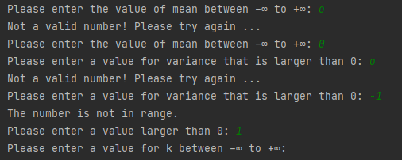

1c)

while True:  
 try:  
 numberx = input("Please enter a value for x between –∞ to +∞: ")  
 numberx = float(numberx)  
 break  
 except ValueError:  
 print("Not a valid number! Please try again ...")

Result:

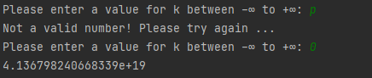

1d)

def calculation (k,mean,var):  
 calculate = math.exp(-(((k - mean ** 2) / (2 * var))))  
 calculate2 = (1 / math.sqrt(2 * 3.14159 * var))  
 finalCal = calculate * calculate2  
 return finalCal

1e)

print(f"The corresponding probability density fX(x) based on the user input is {calculation(k = numberk,mean = number1, var = number2)}.")

Result:



1f)

numberx = -100  
al = 0.01  
fpk=0  
klist = [0.00,1.64,1.94]  
for i in klist:  
 i_replace = i  
 fcalk = 0.00  
 while i_replace >= numberx:  
 fcal = calculation(k=i, mean=number1, var=number2)  
 fcalk = fcalk + fcal  
 i_replace = i_replace - al  
 fpk = al * fcalk  
 print(f"The probability of X in P({numberx}>={i}) is {fpk}.")

Result:

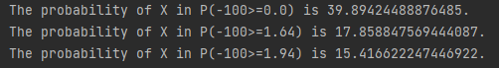

1g)

The compute the result for P(X<=k), first is to create a while loop to keep running the def function calculation(). To retrieve the possibility of in the range of X to k. Secondly, I use the user input value ask in (b) & (c), and place the value into the def function calculation() to generate the possibilities of each number possible outcome in X to k. Thirdly, to ensure the possible outcome are right, I use the expected range of each value to ack the system to run all the values out. In this case, is 0.01, so we ask the system to deduct the 0.01 from k before the loop end to ensure the while continues to loop till the value reaches X(-100). Fourthly, store all the possibilities of P(X<=k, I created fcalk and place it in the loop so that each possibility result generated from the def function calculation() will store in. Next, I create another variable out of the loop, to store the final calculation which is all the possibilities multiply by the 0.01 value to get the final answer for P(X<=k). Lastly, is to make a formatted printing to display the result to the user.

1h)

endx = 5.0  
xlist = {}  
while endx >= -5:  
 fcal = calculation(k=endx, mean=number1, var=number2)  
 xlist[round(endx,1)] = fcal  
 endx = endx - 0.1  
  
xfinding = [2,1.5,1,0.5,0,-0.5,-1,-1.5,-2]  
for key in xlist:  
 for j in xfinding:  
 if key == j:  
 print(f"The probaility of x being {j} is {xlist[key]}.")

Result:

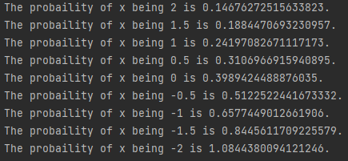

Reference:

Wu, K. Y. (2021). ANL252 Python for data analytics (study guide). Singapore University of Social Sciences.